Group 04 – Data Management Plan 2
Project Name: RehabEdge – Remote Physical Therapy with Edge AI
Wiki Link: https://github.com/Sidduri2025/RehabEdge/wiki/Data-Management-plan-(-Iteration-2)

Summary of Data to Be Stored

1. User Credentials Information
- User ID: A unique identifier for every registered user.
- Email: The login email address used for authentication.
- Password: Stored securely using AES-256 encryption with salted hashing.
- Role: Defines user category (Doctor / Patient / Admin).
- Purpose: Stores all login and authentication-related data for secure system access.

2. Doctor Information
- Doctor ID: A unique identifier for each doctor.
- Name: Full name of the doctor.
- Specialization: Area of expertise (e.g., Orthopedic, Neurology).
- Experience: Years of professional medical practice.
- Availability: Weekly time slots available for consultation.
- User ID (FK): References the UserCredentials table to authenticate login.
- Purpose: Stores doctor-specific profile and scheduling details linked with login credentials.

3. Patient Information
- Patient ID: Unique identifier for each patient.
- Name: Full name of the patient.
- Date of Birth: Used for therapy customization.
- Contact: Phone number or communication preference.
- Assigned Doctor ID (FK): References the supervising doctor.
- Reminder Preference: Frequency of exercise reminders.
- User ID (FK): Links to the UserCredentials table for authentication.
- Purpose: Maintains personal, medical, and communication details of patients.

4. Exercise Details
- Exercise ID: Unique identifier for each exercise.
- Name: Title of the exercise.
- Description: Brief explanation of purpose and method.
- Target Body Part: Body area focused on during exercise.
- Difficulty Level: Categorized as Easy / Moderate / Hard.
- AI Model Reference: Edge AI posture detection model associated with exercise.
- Purpose: Defines the exercise catalog and AI references used during sessions.

5. Session Data
- Session ID: Unique session identifier.
- Patient ID (FK): Patient performing the session.
- Doctor ID (FK): Doctor overseeing the session.
- Exercise ID (FK): Exercise performed during the session.
- Date & Time: When the session occurred.
- Duration: Session length in minutes.
- Accuracy Score: Posture accuracy calculated by AI.
- Feedback Notes: Observations from doctor or AI.
- Video Link: Optional URL to recorded session video.
- Purpose: Records each exercise session with complete AI analytics and supervision metadata.

6. Notification Details
- Notification ID: Unique identifier for each alert or reminder.
- Patient ID (FK): Patient receiving the notification.
- Message: Notification content.
- Type: Delivery mode (Mobile, Email, SMS).
- Status: Sent / Pending / Failed.
- Scheduled Time: When notification is to be triggered.
- Purpose: Stores automated reminder information for exercises, appointments, or missed sessions.

7. Reports Information
- Report ID: Unique identifier for each progress report.
- Patient ID (FK): Patient to whom the report belongs.
- Doctor ID (FK): Doctor who validated the report.
- Generated Date: Date report was created.
- Summary Text: Overview of progress summary.
- Accuracy Trend: Aggregated posture accuracy from sessions.
- Adherence Score: Percentage of exercises completed as prescribed.
- Report Link: Link to downloadable PDF or dashboard visualization.
- Purpose: Generates analytical data for weekly or monthly performance reports for doctors and patients.

8. Data Storage
- Storage ID: Unique identifier for each backup record.
- Backup Date: Timestamp of performed backup.
- File Path: Path to stored data in Azure Blob Storage.
- Encryption Status: Indicates if backup is encrypted.
- Backup Type: Full / Incremental.
- Responsible Admin: Name or ID of the administrator performing backup.
- Purpose: Manages all system backups, versioning, and restoration logs for data integrity.

Data Security Plans

Access Restrictions
- Implement Role-Based Access Control (RBAC) for Doctors, Patients, and Admins.
- Multi-Factor Authentication (MFA) for Doctors and Admins.
- Session Timeout: Automatic logout after 10 minutes of inactivity.
- Authorization Tokens: Renewed per session with limited lifetime.

Encryption
- At Rest: AES-256 encryption for passwords, medical data, and contact information.
- In Transit: TLS 1.3 encryption for all communication channels.

Backup & Recovery
- Full Backups: Daily to Azure Blob Storage.
- Incremental Backups: Every 6 hours.
- Version Control: Each backup stored with metadata for restore operations.

Audit & Monitoring
- Track login attempts, role changes, and data modifications for 90 days.
Alerts triggered for unauthorized access or suspicious activity.

ER Diagram:
The ER Diagram below represents all entities, relationships, and cardinalities according to functional requirements.

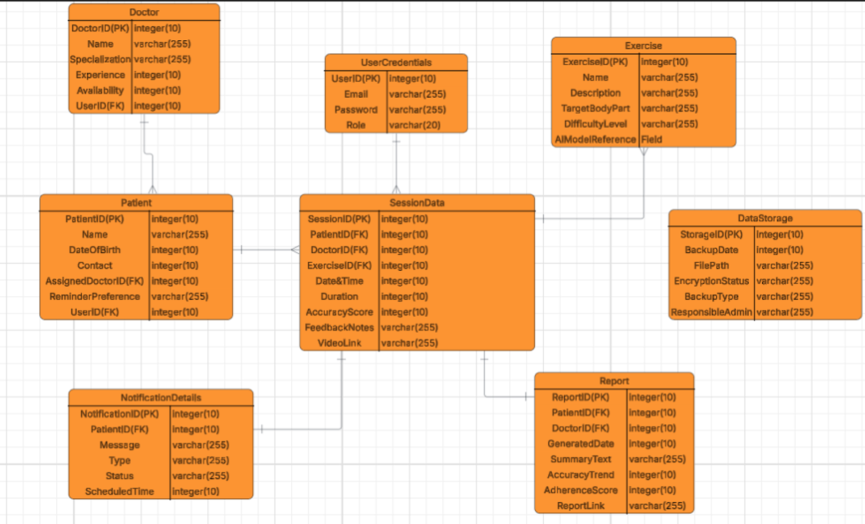

Mapping of Functional Requirements to Data Storage

Functional Requirement | Mapped Entity | Purpose / Description
Create / Update / Delete accounts | UserCredentials, Doctor, Patient | Handles account management and role definition.
Authenticate users securely | UserCredentials | Passwords encrypted and authenticated via AES-256 and salted hash.
Send exercise reminders | Notification | Stores schedule, content, and delivery status.
Capture sessions via device camera | Session, DeviceData | Records session metadata and device linkages.
Store patient exercise history | Session | Tracks duration, feedback, and accuracy.
View weekly progress dashboard | Report, Session | Summarizes accuracy and adherence over time.
Alert for missed sessions | Notification | Triggers alerts for delayed or skipped exercises.
Generate visual progress reports | Report | Aggregates session and AI metrics.
Maintain secure login and MFA | UserCredentials | Enforces secure access for users.
Maintain historical exercise data | Session | Enables historical trend visualization.
Personalized exercise plans | Exercise | Doctor-defined therapy plans.
Manage backup and recovery | DataStorage | Logs all backup and restore activity.
Share reports with caregivers | Report | Generates downloadable or shared reports.

